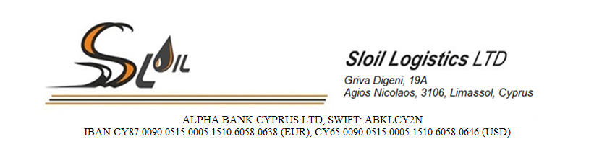

**Partner card**

|  |  |  |
| --- | --- | --- |
| 1 | Company’s name | Sloil Logistics LTD |
| 2 | VAT number | 10359983M |
| 3 | Legal and postal address | 19A, Griva Digeni,  Agios Nikolaos, 3106, Limassol, Cyprus |
| 4 | Phone number  e-mail | Office +35725567010,  Mobile +35797715150  secretary@sloil.com.cy |
| 5 | Registration number and date | HE359983, 13.09.2016 |
| **6** | **Bank, SWIFT** | **ALPHA BANK CYPRUS LTD, ABKLCY2N** |
|  | Bank address | 3, Lemesou Ave. 2112 Aglantzia  Nicosia, Cyprus |
|  | Current account number (USD) | CY65009005150005151060580646 |
|  | Current account number (EUR) | CY87009005150005151060580638 |
| **7** | **Bank, SWIFT** | **Santander Bank Polska S.A., WBKPPLPP** |
|  | Bank address | 00-061 Warszawa, ul. Marszalkowska 142 |
|  | Current account number (USD) | PL77109028510000000149450408 |
|  | Current account number (EUR) | PL56109028510000000149450398 |
| 8 | Directors | Antonis Diomidous  Maryia Tatarchuk  Acting under the Charter |
| 9 | Web-site | www.sloil.com.cy |